Plaque Inscription:

Bert Vaughn of Jacumba built the stone tower in 1922-23 to commemorate the pioneers and road and railroad builders who opened the area. In the 1930s W.T. Ratcliffe carved the stone animal figures which lurk in the rocks surrounding the tower, creating a fantasy world of surprise and strange beauty. This remarkable sculptural assemblage is one of California's exceptional folk art environments.

GPS coordinates for this site: N___________________W_______________

HISTORY

Bert Vaughn (who owned the town of Jacumba) built this 70-foot tall stone lookout laying the cornerstone in concrete in 1922 and completing the structure in 1928. The tower was dedicated in memory of the early travelers and settlers who crossed the desert on their journey between Yuma and the San Diego (it took a month to cross the desert at that time.) The base of the tower is built of solid rock that has withstood not only 60-mile an hour winds during Santa Ana conditions, but also the dynamite blasts during the 1960s when nearby Highway 80 was integrated into the new Interstate 8.

Desert Tower has enjoyed periods of ownership and prosperity, as well as abandonment and neglect as owners of this private park come and go. Dennis A. Newman, a fighter pilot who flew for Britain's Royal Air Force during World War II, bought Desert Tower and added the gift shop around the base so he could sell trinkets and antiques to tourists passing through.

The museum is an interesting collection of artifacts from the Desert Kumeyaay and other peoples mixed with old burlap automobile swamp coolers from the first days of the automobile. Numerous photos and prints also depict the days of western lore. Historic black and white photos provide documentation of the Tower under construction.

On our field trip, we are going to learn about the geology of this area, the ecosystem, and the sense of place that Desert Tower gives the visitor. All of these are components of the Geography of Desert Tower.

First, please start with a walk on the trail. The hand-carved animals, faces, and folk creatures inspired by the natural shapes in the boulders. W.T. Ratcliffe, an unemployed engineer, sculpted the quartz granite boulders in shapes that complimented the surroundings and have been entertaining to hikers since the 1930s. The carvings and tower are registered as California Historical Landmark #939.

Question #1: Hiking to the springs, what are some of the shapes carved into the boulders? Are all the boulders of the same composition?

Question #2: What type of weathering has occurred to shape these boulders?

VIEWSHED

Entering the Desert View Tower, you will see a doorway that leads upstairs to the viewing deck. The top deck affords a vantage of I-8 winding down to the desert floor and eastward. Each window is labeled to identify landmarks shimmering in the distance.

Question #3: How does this Tower fit within the context of the natural environment?

Question #4: Discuss the historical value of this place.

Question #5: Name three of the landmarks you can see from the top deck.

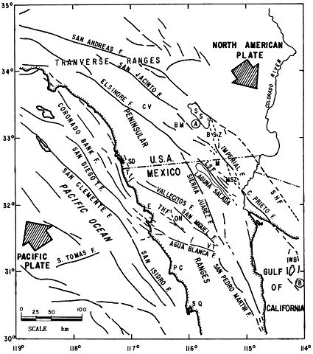
GEOLOGY
Two tectonic plates – the Pacific Plate and the North American Plate, collide here on a Transform or Transverse Boundary. One carries the western zone arc of the Pacific Plate and the other the North American Plate. These plates are covered with relatively low-density (buoyant) crustal rocks. Consequently, neither plate can be forced below the other. This is why we don’t see Convergent Boundary volcanoes at this point in Southern California.

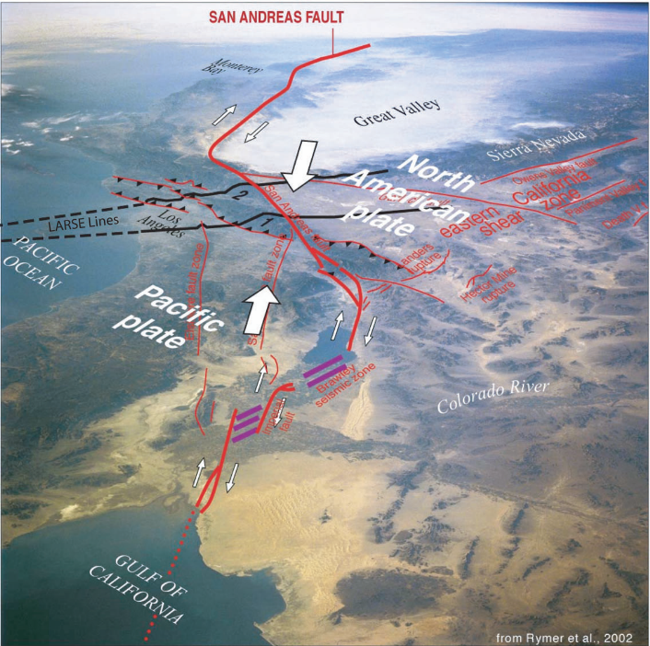
About 5-10 million years ago, the motion of the NE section of the Pacific plate was impeded: Eventually the tectonic plate that was responsible for the So. California and Mexico began to break away. This new motion created a magmatic arc that forms the Peninsular Ranges Batholith, which is visible in the uplifted boulders surrounding Desert Tower. Just east of the tower, in the desert below, runs numerous fault lines. This is the most visible and accessible plate boundary in the world. When you view the ridges of mountains from the tower, you can see the Elsinore, Superstition, and the San Jacinto faults, and beyond, the San Andreas fault.
Shuttle photo of SoCalifornia. Oblique view from the Gulf of California looking toward fault/red - extntional/purple.
Source: USGS.gov
The fault runs from north of (but not actually within) San Francisco at Cape Mendocino south to our border with Mexico, bisecting a good part of Northern California. A plate boundary is a conglomeration of cracks, scarps, depressions, and faults all caused by a collision of two opposing floating plates. At the southeast shoreline of the Salton Sea (near Calipatria) are the Salton Buttes, a line of 5 small active volcanoes that last erupted between 2000 and 2,500 years ago. Obsidian Butte was the source of obsidian – a glass-like black rock - for the Kumeyaay between 510 BC and 640 BC. The Kumeyaay ranged from the Coso Mountains to the San Diego coast. These artifacts are some of the most beautifully crafted projectiles in the world. Other volcanoes in the nearby area include Red Hill, which is extensively quarried, and Rock Hill, a part of the Sonny Bono Salton Sea National Wildlife Refuge. Mullet Island is another volcano that is only accessed by boat. These volcanoes are made of sticky, slow moving Rhyolite lava. The lava at Obsidian Butte cooled quickly, forming glass. There is evidence that the others exhibited Pyroclastic flows – the type produce ash and pumice, and explosive eruptions. Although this produced a more localized ash cloud, however current research is being conducted to find out the range of distribution of the volcanic ash, as well as the Salton Seismic Imaging Project through Caltech and the NSF’s Earthscope project are also assessing the underground “footprint” of this area. Since these volcanoes have erupted numerous times in the geologically recent past, it is a good assumption that this will happen again in the future.

The Salton Buttes show evidence of rhyolite flows, meaning that they put out a thick molten rock at a lower temperature than basalt-based lavas (like that found in Hawaii.) At the time of an eruption, the lava is more like paste than a hot ribbon of glass. However, with the shallow water table associated with the Salton Sea, a steam-charged eruption could occur, which would cause a very different eruption style. In 2009, a series of earthquake swarms occurred in this vicinity, indicating that the magma was rising. Remember, though, that this is an active rift zone, and new rock material is being created as the plates split apart.

When looking at the view to the east and north, you are seeing the Salton Sea. To the south is the Sea of Cortez rift zone, where new land is being formed in the Gulf of California, splitting Baja from mainland Mexico. This is called a Divergent Boundary. The Cerro Prieto volcano is located near sea level on the Colorado River delta, is a 223 meter high compound dacitic lava dome. Dacite lava is primarily made of silica, combined with minerals such as feldspar, pyroxene, and amphibole. Dacite is associated with explosive eruptions. The Cerro Prieto dome was roughly estimated to have formed during a series of events most recently within the past 10,000 years, and like the Salton Buttes, could have erupted more recently than once thought. Cucupas Indian oral tradition tells of a monster that covered the land with hot rocks that grew from the soil and radiated tongues of fire, perhaps referring to an eruption of this volcano.
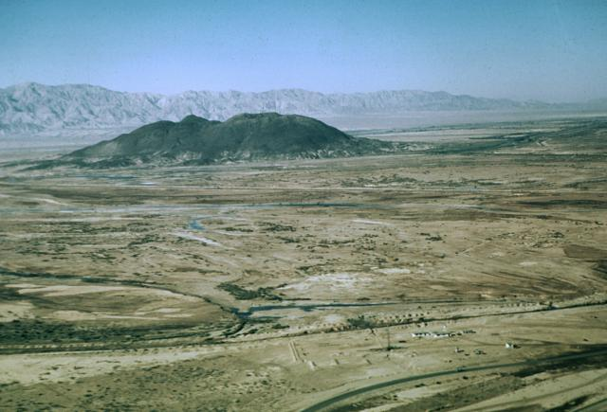
Photo by Marshall Reed, 1959 (U.S. Department of Energy).

Cerro Prieto ("Dark Hill"), a small, 223-m-high compound rhyodacitic lava dome, is the only surficial volcanic feature of the major Cerro Prieto geothermal field, the 2nd largest in North America. Cerro Prieto is the northernmost volcanic field in México and rises above the arid floor of the Imperial Valley at the head of the Gulf of California, 35 km south of the city of Mexicali. The dome consists of rhyodacitic intrusives and lava flows and was constructed along a NE-trending fracture. A 200-m-wide crater is located at the summit of the NE-most dome. (US Dept. of Energy)

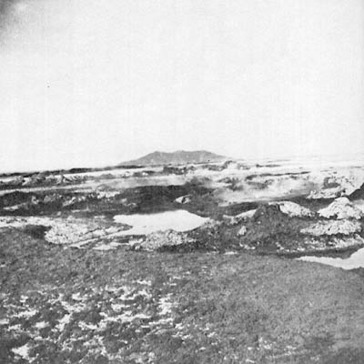
This photo is Circa 1890’s, and is a picture of the mud volcanoes with Cerro Prieto in the background.

This area has CO2 vents, hot brines, and hot springs, along with mud volcanoes and pots.

A mud volcano is the result of underlying tectonics, often associated with Subduction zones and petroleum deposits. Hydrocarbon gases often vent helium when associated with lava volcanoes; however lone mud volcanoes may emit methane.

(San Diego Historical Society)

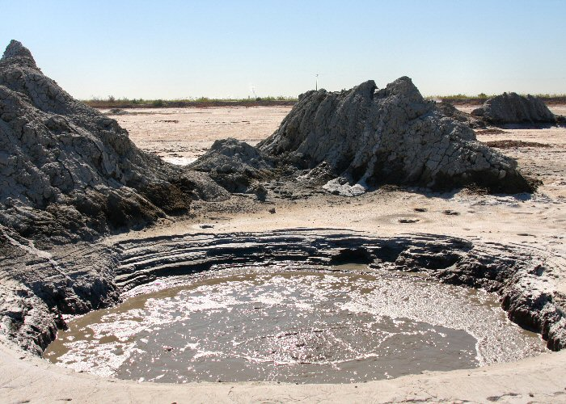
Features associated with mud volcanoes include:

Mud cone – a high cone that is usually less than 10 meters high, and that extrudes mud and rock fragments.

Gryphon - a steep-sided, short cone that effuses mud.

Salse – pool of water with gas seeps, usually giving the appearance of carbonated water.

Spring – pool of water smaller than one half meter.

Mud pot – pool of mud with gas seeps, with bubbling and gas escaping, and often warm or heated mud.

Hot Springs – pools of heated water.

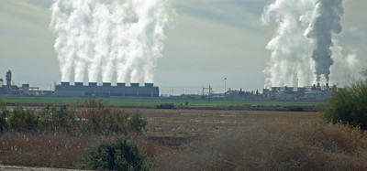
The south end of the Salton Sea had the Salton Sea Geothermal Field, where magma is in close enough proximity to the surface (5-7 miles down) to allow for electrical generation.

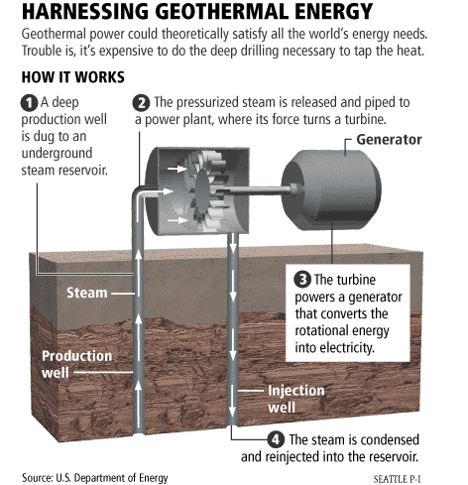

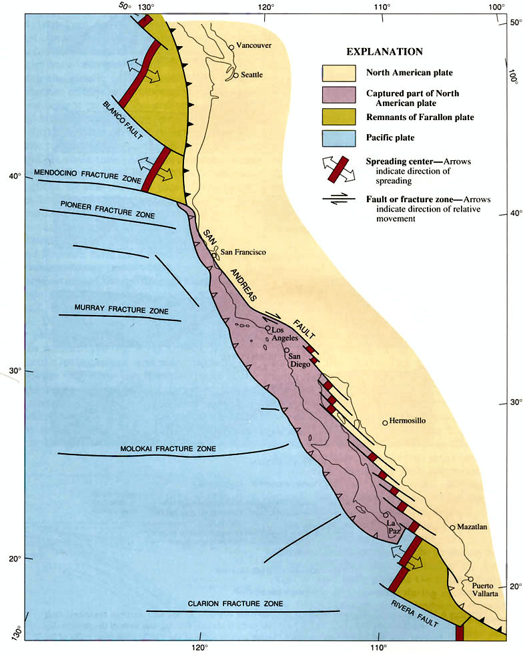Question #6: What type of boundary is the San Andreas? On the map on the page 8, draw big arrows depicting the direction of movement of the two plates (see pg. 1 if you need help.)

Question #7: What are three places where volcanism occurs in the Sea of Cortez rift zone closest to the Salton Sea?

Question #8: What is the difference between mud pots and mud volcanoes?

Question #9: What are the things necessary to have Geothermal power?

Question #10: What are some of the other types of faults along this Boundary?

Question #11: What are types of rock are associated with the Salton Buttes?

#12 - Circle other types of faults on the map on page 5.
In the past, Lake Cahuilla was ephemeral – it was filled in wet years and dried up during droughts. The Colorado River would change course as does any Meandering River type, and the Imperial Valley would change between a marshland and a dry desert. The Salton Sea’s recent formation is due to an irrigation accident in 1905, when the Colorado River was diverted to help farmers, however the engineering was not well conceived, and it was a year of heavy rain. When the river was returned to its course, the Salton Sea remained, and has stayed at a steady depth owing to runoff from farms and natural rainfall. The Salton Sea is approximately 25% saltier than ocean water.

BIOLOGY and BOTANY

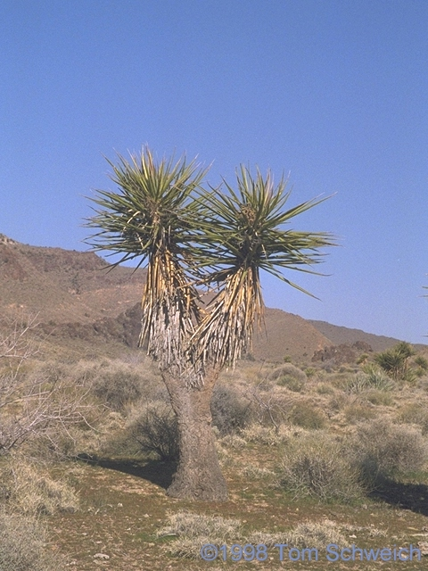
California's Colorado Desert is a part of the larger Sonoran Desert, which extends across southwest North America. The Colorado Desert region encompasses approximately 7 million acres, reaching from the Mexican border in the south to the higher-elevation Mojave Desert in the north and from the Colorado River in the east to the Peninsular mountain range in the west. Just east and below Desert Tower, at the westernmost boundary of Imperial County, straddling Interstate 8 in the Yuha Basin is another sub-region known as Yuha Desert.

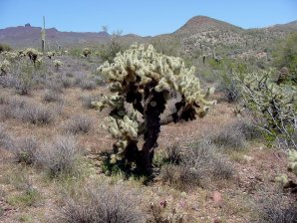
The region's terrestrial habitats include creosote bush scrub; mixed scrub, including yucca (left) and cholla cactus (right); desert saltbush; sandy soil grasslands; and desert dunes. In the Anza-Borrego, slightly higher precipitation from summer monsoon rains smoketree, ironwood, and palo verde trees.

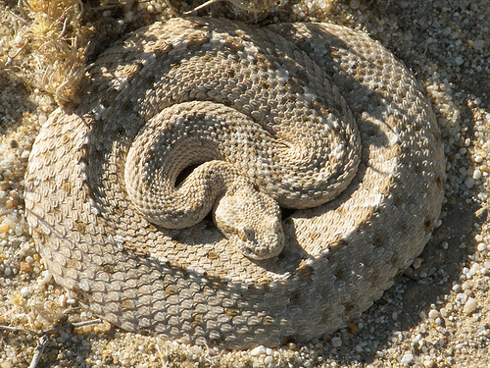
Common desert wildlife includes mule deer, bobcat, desert kangaroo rat, cactus mouse, black-tailed jackrabbit, Gambel's quail, and red-diamond rattlesnake (right).
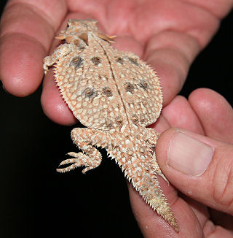
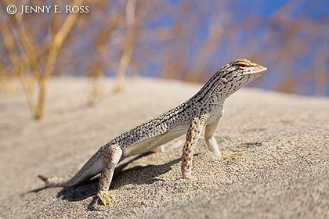
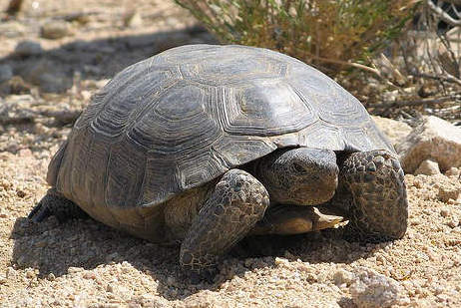
Among sensitive species are Flat-tailed horned lizard (left), Coachella Valley fringe-toed lizard (right), desert tortoise, prairie falcon, Andrews' dune scarab beetle, Peninsular bighorn sheep, and California leaf-nosed bat.

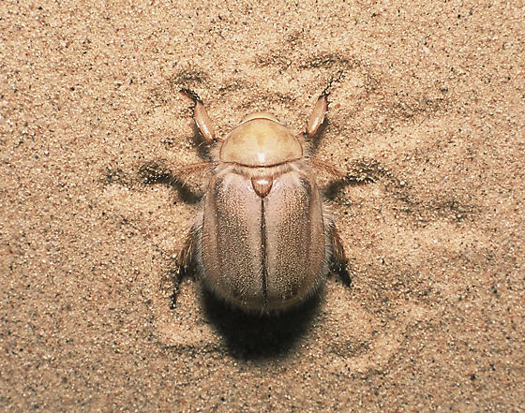
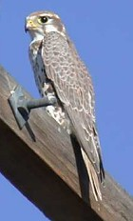
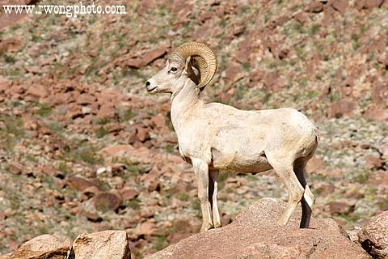

Question #13: What are the ecological limiting factors for the Yuha Desert plants?

Question #14: Where would you expect to see more plants, on the north or south facing slopes? Why?

Question #15: Viewing the animals listed and shown as threatened, what are their adaptations to the ecosystem?

Question #16: What are some of the adaptations of plants to survive in this ecosystem?

PENINSULAR BIGHORN SHEEP

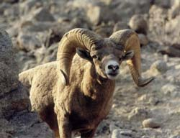
Peninsular Bighorn Sheep have been listed under the California State Endangered Species Act (ESA) since 1971, however they continue decline in numbers. Habitat loss for Peninsular bighorn exacerbated this situation and in March, 1998 the population was finally federally listed as endangered. The U.S. Fish & Wildlife Service (FWS) determined that Peninsular Bighorn sheep were in danger of extinction throughout a significant portion of their range due to: (1) disease from domestic cattle; (2) insufficient lamb recruitment; (3) habitat loss, degradation, and fragmentation by urban and commercial development; and (4) predation coinciding with low population numbers. Reduced from 1,200 pairs in 1971 to just 280 in 1997, the Peninsular Bighorn’s habitat extends throughout the desert areas of Southern California.

Question #17: What are some of the pressures exerted in this ecosystem that have led to the decline of the Peninsular Bighorn?

Question #18: What do these have in common with the other threatened and endangered species we have studied in this class?

Thank you for participating: I hope that you had a good time and learned something of value today. Please hand in this worksheet at our next class meeting.

