Name_________________________________
Class, Day & Time______________________

Human/Cultural Geography
San Diego Trolley Field Trip

Stop 1: City College (Downtown San Diego)
From this vantage, we can see the San Diego Bay to the west of the College, with the urban landscape predominating. At this location, the natural systems are now paved and planned landscapes and hardscapes. The original ecosystem would have been sand and salt flats, salt marshes, and grassland.

From the south end of San Diego Bay, across and through Downtown San Diego is the Rose Canyon fault, which runs north to Torrey Pines, north of La Jolla. Although this fault is rarely active, it is part of the Pacific Plate, which is skidding north along the North American Plate.

▪When proceeding through the City of San Diego, what visual cues do you see in the landscape to alert you of changing neighborhoods?

▪The Santa Fe Station serves not only the trolley, but also Amtrak and the Coaster trains. How has increased mass transit changed the way San Diegans commute?

▪When proceeding toward Old Town, how does the pattern of development change?

Stop 2: Old Town

Old Town was the original “downtown” San Diego. You will be walking through to the park and visiting a few of the exhibits. This area is now a State Park. When you enter the Robinson-Rose house, you will see a model of Old Town as it was. Although difficult to see in the photographs, this was a major town with surrounding agricultural interests, water resources, and cultural centers. The Presidio and the Mission de Alcala were nearby as well.

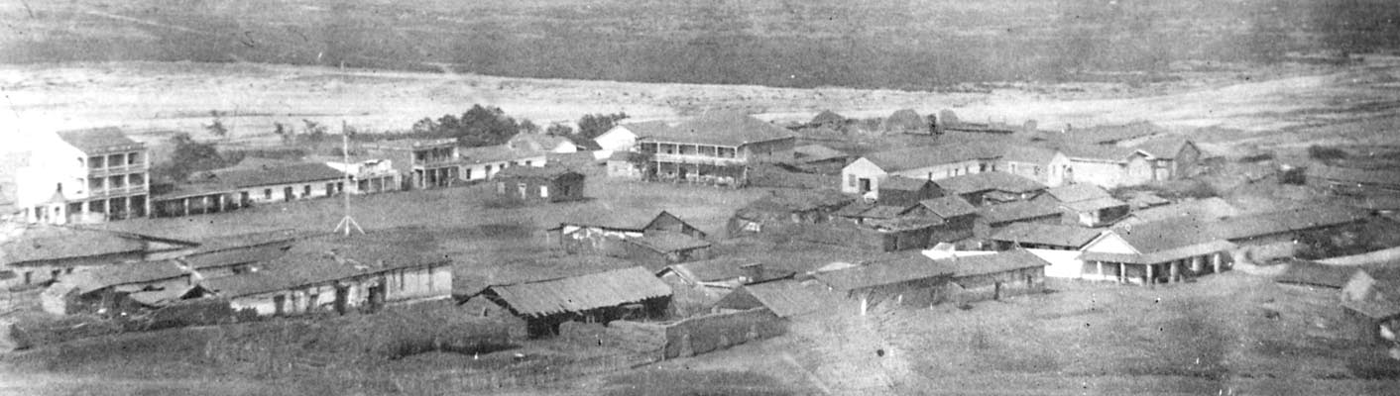
When you cross the street into the park, turn left toward the McCoy house museum to see the gardens for the questions on this part of the worksheet. Also, look into the windows at this museum. James McCoy was an Irish immigrant who became Sheriff of San Diego, and later State Senator.
▪Does the construction of this house have the look of a new or old home? What are the characteristics of the house that speak of its place in time?

▪Old Town Garden: What type of plants would have grown here before the settlers came?

▪When was San Diego settled by the La Jollan complex of people? The Kumeyaay? The European Settlers? How were their settlements different?

▪What kinds of plants were valued in the kitchen garden of the early European Settlers? What kinds of plants are currently growing here?

▪The trees are unique in this area. What dominates the landscape? What would have been here 150 years ago? Why?

▪What weather patterns would have influenced the choices of the early European settlers as well as proximity to what resources?

▪The Cosmopolitan Hotel was built in 1873 - a time when materials were expensive, so the exterior Adobe was constructed to look like another material. What is this made to resemble?

Stop 3: Mission Valley

This area was once open farmland that included dairies and rice fields. There were seasonal flood episodes that kept the land fertile. There are now 2 dams on this river that give us both water storage and protection from seasonal flooding. Lake Murray and Lindo Lake are also resources for recreation and wild bird migrations. Along the San Diego River is also one of the largest urban parks in the country, Mission Trails Regional Park.

Along the mesas above Mission Valley were Vernal Pools – seasonal pools with tiny San Diego Mesa Mint and a type of freshwater shrimp that only occurs in this ecosystem. Lakes that only hold water seasonally are known as “Vernal Pool”, and are rare now in San Diego. Genetic diversity in the pools was accomplished by mud on the hooves of deer and antelope who would wander in and out of the pools.

Ninety-six percent of all Vernal Pools in San Diego County have been destroyed by urbanization. These seasonal pools are now critically endangered, and all Vernal Pools are protected by law.

▪Please describe the vegetation as you seen them during your field trip. Think about what kind of character they give to San Diego.

▪ Please describe the appearance of the San Diego River in Mission Valley. At this location, does the San Diego River flow above or below ground?

▪ What kinds of things can you see from the Trolley in Mission Valley in terms of landscape and economic development?

▪ Are there signs in Mission Valley that are distinctly San Diegan? What are the symbols of Globalization?

▪ How does the main freeway, Interstate 8, and the Trolley Line through the Valley make a statement about the City of San Diego?

▪What are the visual cues that can be considered archives of San Diego history in the landscape?

▪Please describe the land uses in Mission Valley and how they interface with the San Diego River.

Stop 4: Grantville Stop

On the slopes adjacent to where you stand, many of the locally indigenous plant species have been displaced by non-indigenous invasive species. Urbanization has crowded out the native species in the valley, and the river and its tributaries have been squeezed and channeled into small areas.

Along the eastern edge of Waring Road and the northern edge of Mission Valley is the Navajo Canyon Open Space preserve. There is a hiking trail that is open to the public into this canyon, which also serves as a wildlife corridor.

▪What is the importance of Wildlife Corridors for San Diego?

▪Within Mission Valley and the surrounding mesas, which exhibit a higher concentration of development? Why do you think that this occurred?

▪Please describe urban runoff as it pertains to this site.

▪Please note the change in land uses in this area. Does this indicate a particular economic geography?

▪Returning to the trolley, you will proceed toward SDSU. How are the canyons on the southern side of Mission Valley different from those on the northern side. What might account for this?

Stop 5: San Diego State University: Public Art

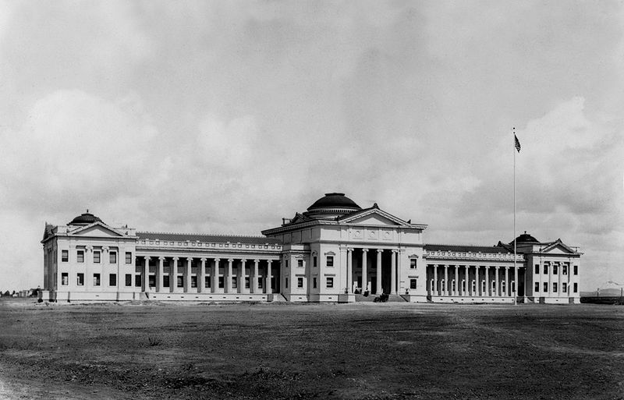
San Diego State University has been a part of the San Diego community for over 116 years, and continues to be a touchstone for education in the community.

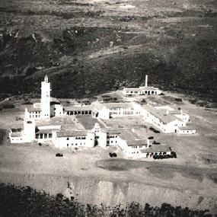
It has a definite sense of place that fits into the larger picture of San Diego by harkening back to Mission Revival, incorporating touches of the mission style in each of the buildings.

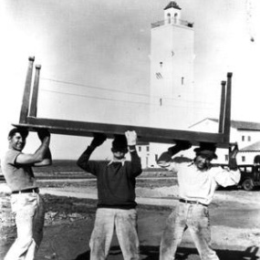

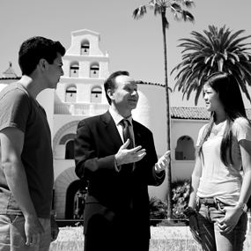

▪ Proceed through a tunnel to the San Diego State University stop. The students refer to this as “The Tube.” How is the “look and feel” different at this stop than the other stops?

▪What are examples of Public Art at this location (Hint: Look up, look on the ground, etc.)?

▪Proceed to the mezzanine level and go outside: At this north-facing vantage point, you have a sweeping view of campus. Count the buildings in your viewshed that exhibit Mission Revival architecture.

▪How is this integrated into the larger SDSU Campus sense of place?

▪What is distinctive about the landscape architecture and walkways associated with this stop?

Stop 6: La Mesa and El Cajon (stop is in El Cajon)

“Director's Statement” From The Journal of San Diego History Spring 2002, Volume 48, Number 2
The early cinematic history of San Diego mirrors the events and developments in motion pictures, both artistic and technological, that were occurring in New York and Los Angeles, as well as in Europe.

The birth of the industry on the West Coast was marked by a number of individual milestones, one of which was the filming in 1898 in downtown San Diego of a moving trolley by The Edison Company to demonstrate the marvel of Thomas Alva Edison’s newest invention. The film lasts 50 seconds.

The magic was in the technology; even though figures moved jerkily in stops and starts across the screen, they did move and the public was fascinated. Today’s seamless movies let us forget that the basis of motion pictures is still the same: innumerable still images put before the eye in rapid succession.

By 1910, technology had advanced to the point that artistry became paramount, the focus shifting to a good story, talented actors and imaginative scenery. La Mesa and Lakeside became the setting for some 150 silent movies, rivaling locations anywhere and looming for awhile as a possible capital of filmdom.

You will pass through La Mesa before heading into El Cajon. La Mesa is situated in the lower foothills of the county, and experiences a cooler microclimate in the winter, warmer in the summer. La Mesa is also the home to not only a quaint downtown, but also the revitalized Grossmont Shopping Center. The city is fully built out, and is now in the process of removing less dense uses in favor of greater density. The city has 2 Trolley Tracks running through it, one in the downtown, the other along the shopping center edge. Currently, the city has approved building condominiums along this corridor to increase housing units in the area.

Historically, both La Mesa and its southern neighbor, Lemon Grove, were widely agricultural, with (of course) Lemon groves and other citrus, and small dairies. Further east, El Cajon was a grape growing center for California for many years. The region receives moderate precipitation, averaging 9 to 12 inches per year in the form of both rainfall and fog. Lake Murray in La Mesa is still a great place to find migrating birds and you can find abundant butterflies in local gardens and parks.

You will be getting off the Trolley at El Cajon. This is a very different view of this river. As you have seen, the river is now channalized, and at this time there is not a single natural section of the San Diego River in El Cajon. This has led to a high concentration of run-off and pollution running unimpeded into the San Diego River. Without the plant life to absorb the concentrations of runoff fertilizers and chemicals, this part of the river poses the highest danger to the rest of the river overall.

▪Please describe the development types found as you proceed past Grossmont Trolley Center. How is this landscape and development changing?

▪Is the Trolley housing development a sign of Globalization or Environmentalism or both?

▪Please describe the difference between the type of development you have seen in Mission Valley and that found in La Mesa. Are they becoming more similar? Why/why not?

▪When proceeding to El Cajon, what are the differences in landscape and development between La Mesa and El Cajon?

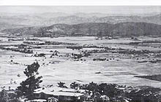 |  | 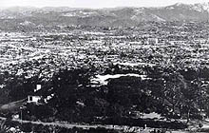
El Cajon Valley  1937 |  | El Cajon Valley  1987

From El Cajon Historical Society website http://www.elcajonhistory.org/echs_ecstreet.htm
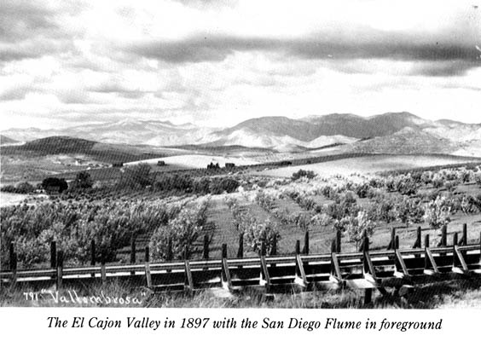
El Cajon
In the early part of the 1800s the mission padres sought pasture land, which led them to “the box” - El Cajon Valley. The foothills are both a watershed boundary and a simple way to divide land. When California became independent from Spain, the Spanish Dons began take over the vast properties of the Roman Catholic Missions. With secularization, California Governor Pio Pico in 1845 seized the lands of Mission San Diego de Alcala and granted the El Cajon Valley to Dona Maria Antonio Estudillo, wife of Don Miguel de Pedrorena. The grant included generally the present communities of Lakeside, Santee, Bostonia, Glenview, Johnstown, El Cajon, and part of Grossmont. The Pedrorenas resided in San Diego, and did not develop the land. A few homesteader or “squatter” homes of adobe construction were erected in the area during the mid 1800s, but nothing permanent.
El Cajon passed hands to other developers, who used the natural corridors which made Main and Magnolia the crossroads from San Diego to gold mining operations in Julian and the City of San Diego. Lankershim, a San Francisco developer, bought the bulk of the Pedrorena's Rancho Cajon holdings in 1868. Lankershim subdivided the land into large tracts for wheat ranching. However, the soil and climate supported almost any crop. Within a few years El Cajon was a successful farming center for citrus, avocados, grapes, and raisins.
El Cajon, California, 1900 by Victor Geraci, The Journal of San Diego History, Fall 1990, Volume 36, Number 4
Mrs. Hazel Sperry, former Secretary and Curator of El Cajon Historical Society, for much of the source material upon which this historical account is based.

▪El Cajon displays what predominant development style?

▪Are there any cultural cues in the landscape? Please name those cues you see in the landscape, and who or what they reflect?

▪How much open space do you see in El Cajon and La Mesa? Does this affect the “look and feel” and the sense of place for these two cities?

Stop 7:Santee Trolley Center – Final Stop

Santee is a “new town” in many respects. The building boom of the 1990s brought a planned town center, with suburban development for housing. The Mission Trails Regional Park extends through Santee, linking via the old Camp Elliott with Mira Mar Marine Air Station. This open space is critical to the survival of many species of wildlife, as well as to the migratory birds on the Pacific Flyway.

▪Please describe the habitat types found at this location.

▪Please describe the San Diego River stream channel at this location.

▪How is the development in this area different from that found in La Mesa? Mission Valley? San Die

▪Please describe the importance of Mission Trails Park to the region.

Thank you for participating: I hope that you had a good time and learned something of value!

