**Correlation Table (ALL Date on ONE PAGE, size image images appropriately, DON’T Split between pages)**

Tutorial on how to ‘word process’ FTIR correctly ([click here](https://www.youtube.com/watch?v=uke3JThLAFY&index=12&list=PLe4gx1I3EX3cWtu9um-TFkRsGrl4cHcZ0)) – Use four signifant figures maximum to report IR frequencies.

|  |  |  |  |
| --- | --- | --- | --- |
| Specific Functional Group | Observed Frequency Vibration (cm–) | Intensity | Shape |
|  |  |  |  |
|  |  |  |  |
|  |  |  |  |
|  |  |  |  |
|  |  |  |  |
|  |  |  |  |

**Experimental FT-IR Spectrum – shown as FULL-SCALE YOUR SPECTRUM (see sample below)**

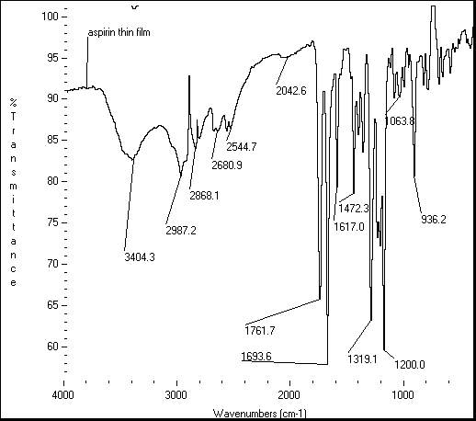

**Actual FT-IR Spectrum – Right Justified and Aligned 2000 & 1000 marks (see sample below)1**

|  |  |
| --- | --- |
| Include Structure (sample below) |  |

1. STATE REFERENCE (for example <http://aist.go.jp/RIODB/SDBS/sdbs> )