Exam 3 covers BOTH lecture and lab and is worth 150 points
Please see the lecture exam study guide as well.

MENDELIAN GENETICS
- Be able to solve monohybrid crosses, dihybrid crosses and other problems like the ones in your lab manual.
- Be able to solve problems when alleles are codominant or incompletely dominant and to recognize codominance or incomplete dominance based on patterns of inheritance.

Tutorial &Practice Problems:
http://www.k-state.edu/biology/pob/tutorials.html

MOLECULAR GENETICS
- Given a DNA sequence, be able to draw the complementary strands formed when DNA replicates.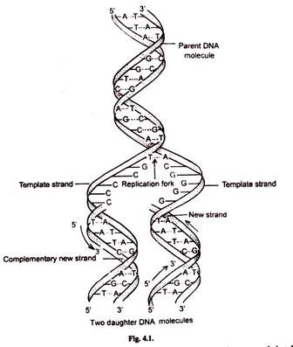
- Given a DNA sequence, be able to write the mRNA (transcription) and determine the amino acid sequence forming the protein (translation). You will be given a circular amino acid chart like the one shown below
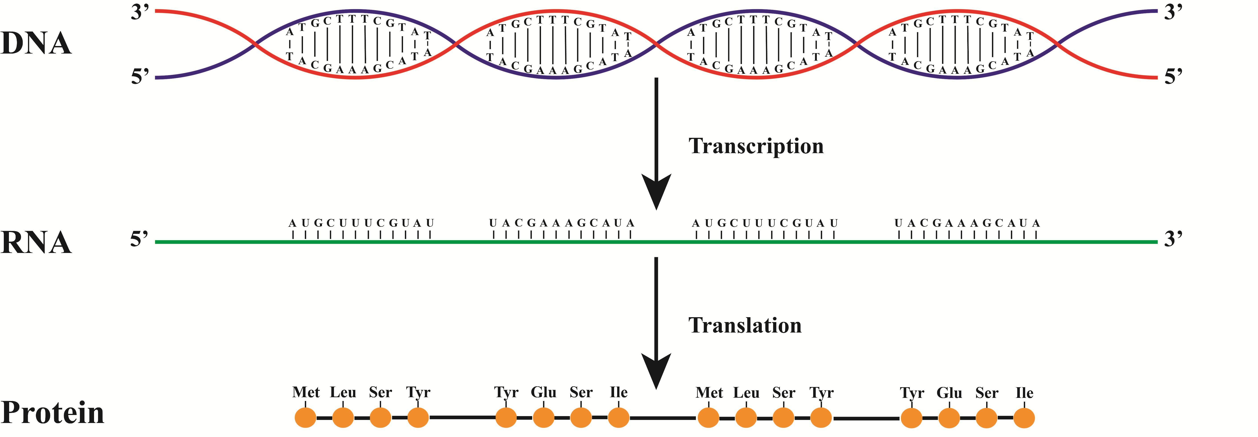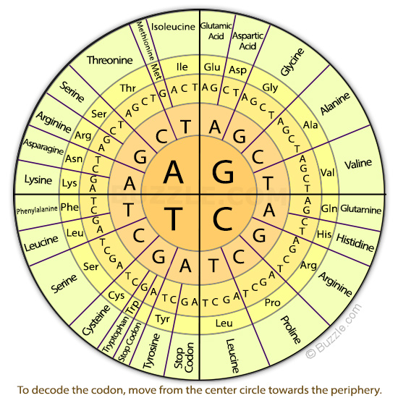

BIOTECHNOLOGY
- Explain how you extracted DNA from a strawberry and what each step of the process was for (ie. why use detergent?).

FLOWERS, POLLINATION, SEEDS, FRUIT, DISPERSAL,
- see lecture study guide and practice PowerPoint. You will be given word bank of inflorescence types and a copy of the key to pollinators in your lab manual.

PLANT ECOLOGY
- Review the handout from the Mission Trails Regional Park field trip; know all the terms and be able to answer all the questions.

